February 14, 2022

Dear Third-Year Physics & Astronomy Graduate Students,

I hope this finds you well and enjoying your work. Attached is a copy of the *Ph.D. Thesis Proposal Application*, which you should discuss and fill in with your advisor.

With the effects of the pandemic finally winding down, the Graduate Curriculum and Policy Committee has decided to reinstate the original timeline for the research proposal process. Accordingly, you should submit a complete application form to the Department Office no later than **Friday,** **April 15**, and attempt the proposal examination no later than **Friday, May 13.** Any request to delay the thesis proposal must be made in writing to the Graduate Curriculum and Policy Committee no later than **April 15** as well.

Detailed information about the procedures for assembling an examination committee and presenting your research proposal is included in the *Graduate Student Handbook* (please see in particular **pages 29-30**). In addition, I will be available to answer any relevant question that may arise.

Best wishes for a continued productive term.

Sincerely,

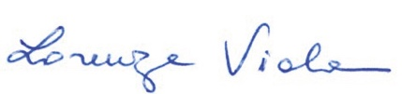

Lorenza Viola

*Graduate Adviser*

*(ex officio member of the Graduate Curriculum and Policy Committee)*

**Attachment**

**Distribution:**

Thomas Boudreaux Grayson Petter

Aylin Garcia Soto Jules van Irsel

Brent Harrison Weishi Wang

Muhammad Khan Jacob Willard

Magdalina Moses Jackson Yant

Sarah Peery